SQL Like and Wildcards

🌟 Definition
# Source: AI Source: Provided by: [Data Path: Persons Table -> ID Column: 1, Name_En Column: Motasem Essam] -> From: [ChatGPT] on [6/11/2026]
The SQL LIKE operator is used to search for a specific pattern in a text column.
It is commonly used with the WHERE clause to find records that partially match a value instead of requiring an exact match.
Wildcards are special characters used with LIKE to represent unknown or variable characters.

🎯 Purpose
# Source: AI Source: Provided by: [Data Path: Persons Table -> ID Column: 1, Name_En Column: Motasem Essam] -> From: [ChatGPT] on [6/11/2026]
LIKE and wildcards are used to:
- Search for names beginning with a letter
- Find words ending with a suffix
- Search for partial text
- Match patterns in strings
- Filter text without knowing the exact value

🧠 Simple Example
# Source: AI Source: Provided by: [Data Path: Persons Table -> ID Column: 1, Name_En Column: Motasem Essam] -> From: [ChatGPT] on [6/11/2026]
Customers Table
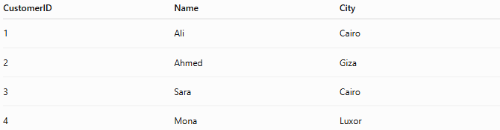
CustomerID | Name | City
1 | Ali | Cairo
2 | Ahmed | Giza
3 | Sara | Cairo
4 | Mona | Luxor

SQL Statement
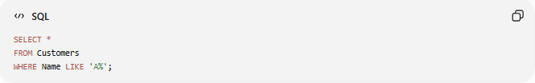
SELECT *
FROM Customers
WHERE Name LIKE 'A%';

Result
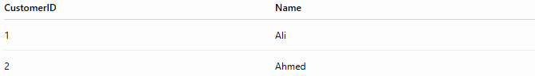
CustomerID | Name
1 | Ali
2 | Ahmed
Returns names that start with "A".

📝 Syntax
# Source: AI Source: Provided by: [Data Path: Persons Table -> ID Column: 1, Name_En Column: Motasem Essam] -> From: [ChatGPT] on [6/11/2026]
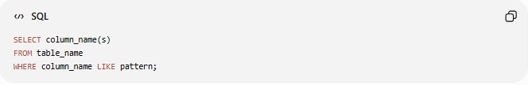
SELECT column_name(s)
FROM table_name
WHERE column_name LIKE pattern;

🌟 SQL Wildcards
# Source: AI Source: Provided by: [Data Path: Persons Table -> ID Column: 1, Name_En Column: Motasem Essam] -> From: [ChatGPT] on [6/11/2026]
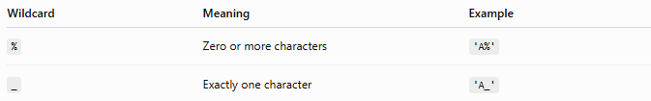
Wildcard | Meaning | Example
% | Zero or more characters | 'A%'
_ | Exactly one character | 'A_'
Note: The % and _ wildcards are supported by MySQL, SQL Server, PostgreSQL, MariaDB, and many other SQL databases.

1️⃣ Percent (%) Wildcard
# Source: AI Source: Provided by: [Data Path: Persons Table -> ID Column: 1, Name_En Column: Motasem Essam] -> From: [ChatGPT] on [6/11/2026]
The % wildcard represents zero, one, or many characters.

Example 1: Starts With
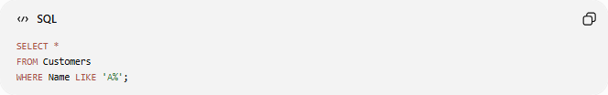
SELECT *
FROM Customers
WHERE Name LIKE 'A%';
Result
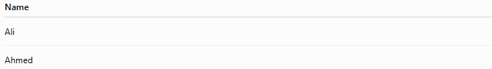
Name
Ali
Ahmed
Names begin with A.

Example 2: Ends With
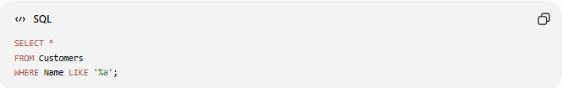
SELECT *
FROM Customers
WHERE Name LIKE '%a';
Result
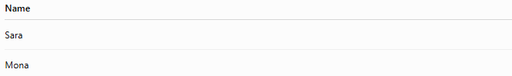
Name
Sara
Mona
Names end with a.

Example 3: Contains
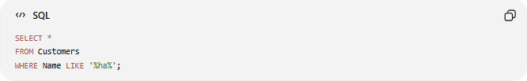
SELECT *
FROM Customers
WHERE Name LIKE '%ha%';
Result
Name
Ahmed
Names containing "ha" anywhere are returned.

Example 4: Any Value
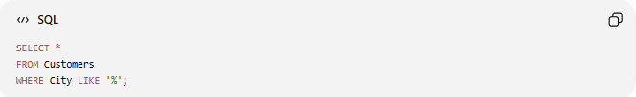
SELECT *
FROM Customers
WHERE City LIKE '%';
Returns every row because every text value matches %.

2️⃣ Underscore (_) Wildcard
# Source: AI Source: Provided by: [Data Path: Persons Table -> ID Column: 1, Name_En Column: Motasem Essam] -> From: [ChatGPT] on [6/11/2026]
The _ wildcard represents exactly one character.

Example 1
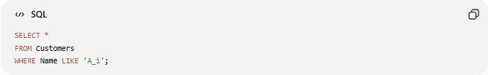
SELECT *
FROM Customers
WHERE Name LIKE 'A_i';
Result
Name
Ali
The pattern means:
- First letter = A
- Second letter = any one character
- Third letter = i

Example 2
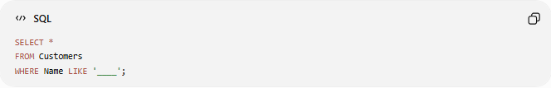
SELECT *
FROM Customers
WHERE Name LIKE '____';
Result
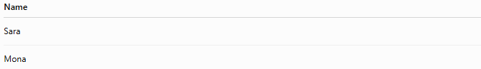
Name
Sara
Mona
Returns names with exactly 4 letters.

📚 More LIKE Examples
# Source: AI Source: Provided by: [Data Path: Persons Table -> ID Column: 1, Name_En Column: Motasem Essam] -> From: [ChatGPT] on [6/11/2026]
Begins with "M"
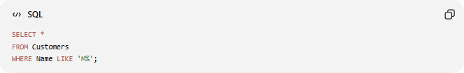
SELECT *
FROM Customers
WHERE Name LIKE 'M%';

Ends with "d"
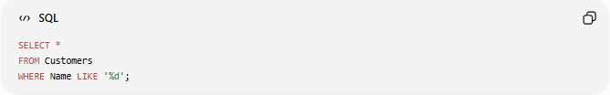
SELECT *
FROM Customers
WHERE Name LIKE '%d';

Contains "ar"
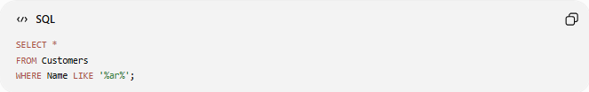
SELECT *
FROM Customers
WHERE Name LIKE '%ar%';

Second Letter is "o"
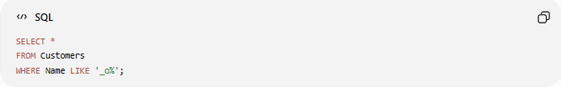
SELECT *
FROM Customers
WHERE Name LIKE '_o%';

Exactly Five Characters
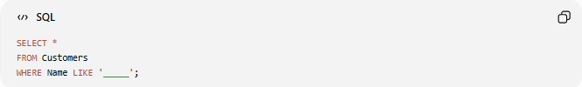
SELECT *
FROM Customers
WHERE Name LIKE '_____';

📊 Common LIKE Patterns
# Source: AI Source: Provided by: [Data Path: Persons Table -> ID Column: 1, Name_En Column: Motasem Essam] -> From: [ChatGPT] on [6/11/2026]
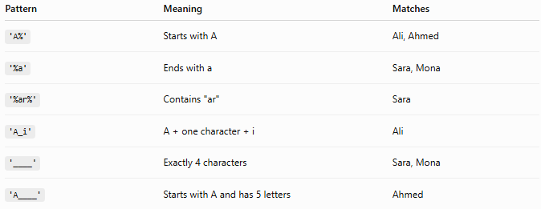
Pattern | Meaning | Matches
'A%' | Starts with A | Ali, Ahmed
'%a' | Ends with a | Sara, Mona
'%ar%' | Contains "ar" | Sara
'A_i' | A + one character + i | Ali
'____' | Exactly 4 characters | Sara, Mona
'A____' | Starts with A and has 5 letters | Ahmed

📚 LIKE with WHERE
# Source: AI Source: Provided by: [Data Path: Persons Table -> ID Column: 1, Name_En Column: Motasem Essam] -> From: [ChatGPT] on [6/11/2026]
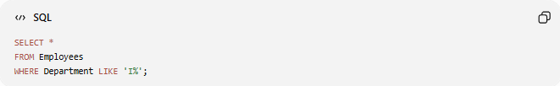
SELECT *
FROM Employees
WHERE Department LIKE 'I%';
Returns departments beginning with I, such as IT.

📚 LIKE with NOT
# Source: AI Source: Provided by: [Data Path: Persons Table -> ID Column: 1, Name_En Column: Motasem Essam] -> From: [ChatGPT] on [6/11/2026]
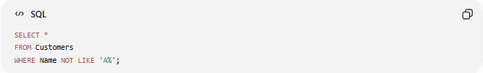
SELECT *
FROM Customers
WHERE Name NOT LIKE 'A%';
Returns customers whose names do not begin with A.

📚 LIKE with AND
# Source: AI Source: Provided by: [Data Path: Persons Table -> ID Column: 1, Name_En Column: Motasem Essam] -> From: [ChatGPT] on [6/11/2026]
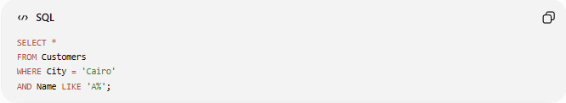
SELECT *
FROM Customers
WHERE City = 'Cairo'
AND Name LIKE 'A%';
Returns customers who:
- Live in Cairo
- Have names beginning with A

📚 LIKE with OR
# Source: AI Source: Provided by: [Data Path: Persons Table -> ID Column: 1, Name_En Column: Motasem Essam] -> From: [ChatGPT] on [6/11/2026]
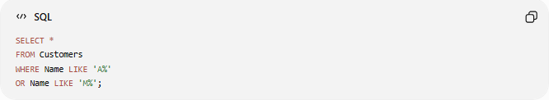
SELECT *
FROM Customers
WHERE Name LIKE 'A%'
OR Name LIKE 'M%';
Returns names beginning with A or M.

🧪 Complete Test Example

1️⃣ Create Table
# Source: AI Source: Provided by: [Data Path: Persons Table -> ID Column: 1, Name_En Column: Motasem Essam] -> From: [ChatGPT] on [6/11/2026]
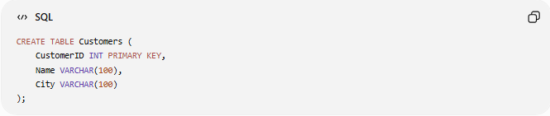
CREATE TABLE Customers (
CustomerID INT PRIMARY KEY,
Name VARCHAR(100),
City VARCHAR(100)
);

2️⃣ Insert Sample Data
# Source: AI Source: Provided by: [Data Path: Persons Table -> ID Column: 1, Name_En Column: Motasem Essam] -> From: [ChatGPT] on [6/11/2026]
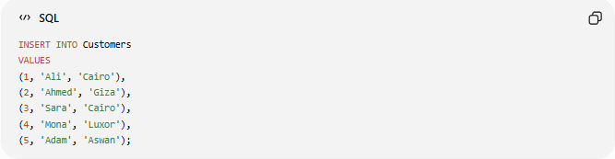
INSERT INTO Customers
VALUES
(1, 'Ali', 'Cairo'),
(2, 'Ahmed', 'Giza'),
(3, 'Sara', 'Cairo'),
(4, 'Mona', 'Luxor'),
(5, 'Adam', 'Aswan');

3️⃣ Starts with A
# Source: AI Source: Provided by: [Data Path: Persons Table -> ID Column: 1, Name_En Column: Motasem Essam] -> From: [ChatGPT] on [6/11/2026]
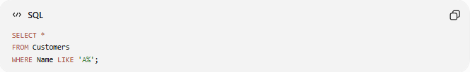
SELECT *
FROM Customers
WHERE Name LIKE 'A%';

4️⃣ Ends with a
# Source: AI Source: Provided by: [Data Path: Persons Table -> ID Column: 1, Name_En Column: Motasem Essam] -> From: [ChatGPT] on [6/11/2026]
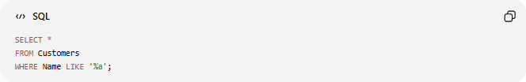
SELECT *
FROM Customers
WHERE Name LIKE '%a';

5️⃣ Contains "am"
# Source: AI Source: Provided by: [Data Path: Persons Table -> ID Column: 1, Name_En Column: Motasem Essam] -> From: [ChatGPT] on [6/11/2026]
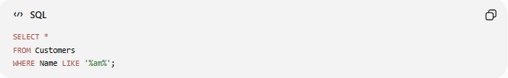
SELECT *
FROM Customers
WHERE Name LIKE '%am%';

6️⃣ Exactly Four Letters
# Source: AI Source: Provided by: [Data Path: Persons Table -> ID Column: 1, Name_En Column: Motasem Essam] -> From: [ChatGPT] on [6/11/2026]
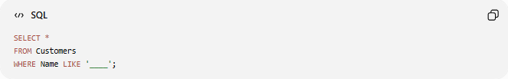
SELECT *
FROM Customers
WHERE Name LIKE '____';

7️⃣ Second Letter is "o"
# Source: AI Source: Provided by: [Data Path: Persons Table -> ID Column: 1, Name_En Column: Motasem Essam] -> From: [ChatGPT] on [6/11/2026]
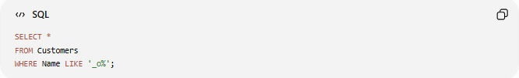
SELECT *
FROM Customers
WHERE Name LIKE '_o%';

Real Example

prepared commands

1️⃣ Create Table
# Source: ScreenShot Source: Provided by: [Persons Table -> ID Column: 1, Name_En Column: Motasem Essam] -> Tool: [Automation Table -> ID Column: 16, Name_En Column: Screen Capture] -> From [Operating System: Wampserver64 -> phpmyadmin] on [6/11/2026]
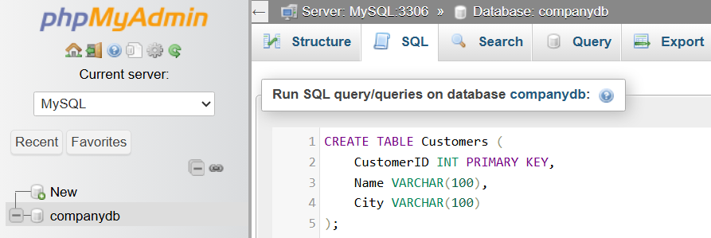
CREATE TABLE Customers (
CustomerID INT PRIMARY KEY,
Name VARCHAR(100),
City VARCHAR(100)
);
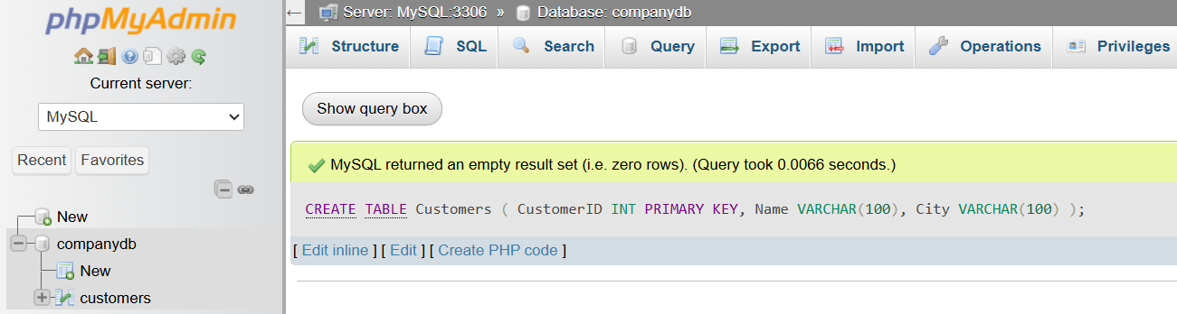

2️⃣ Insert Sample Data
# Source: ScreenShot Source: Provided by: [Persons Table -> ID Column: 1, Name_En Column: Motasem Essam] -> Tool: [Automation Table -> ID Column: 16, Name_En Column: Screen Capture] -> From [Operating System: Wampserver64 -> phpmyadmin] on [6/11/2026]
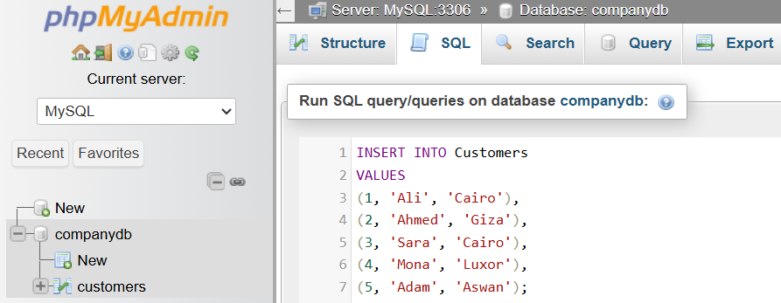
INSERT INTO Customers
VALUES
(1, 'Ali', 'Cairo'),
(2, 'Ahmed', 'Giza'),
(3, 'Sara', 'Cairo'),
(4, 'Mona', 'Luxor'),
(5, 'Adam', 'Aswan');
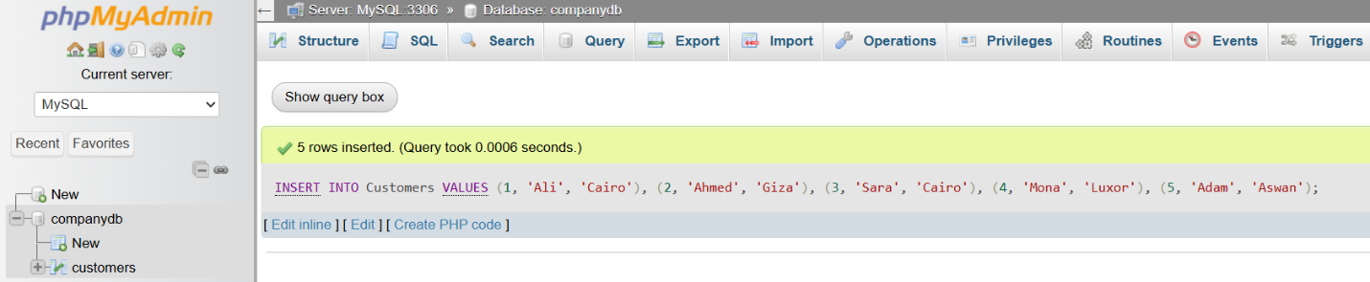

basic command

3️⃣ Starts with A
# Source: ScreenShot Source: Provided by: [Persons Table -> ID Column: 1, Name_En Column: Motasem Essam] -> Tool: [Automation Table -> ID Column: 16, Name_En Column: Screen Capture] -> From [Operating System: Wampserver64 -> phpmyadmin] on [6/11/2026]
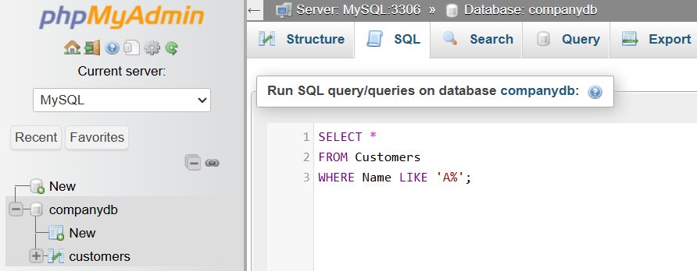
SELECT *
FROM Customers
WHERE Name LIKE 'A%';
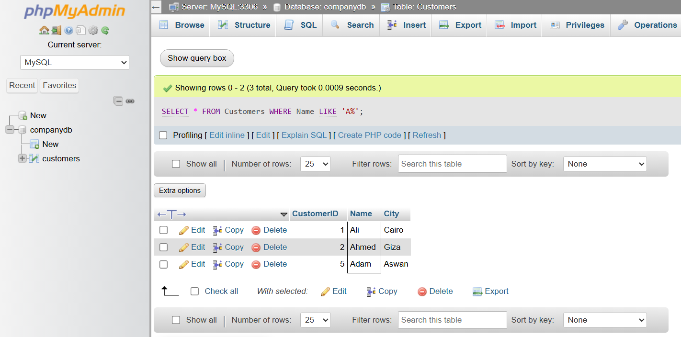

4️⃣ Ends with a
# Source: ScreenShot Source: Provided by: [Persons Table -> ID Column: 1, Name_En Column: Motasem Essam] -> Tool: [Automation Table -> ID Column: 16, Name_En Column: Screen Capture] -> From [Operating System: Wampserver64 -> phpmyadmin] on [6/11/2026]
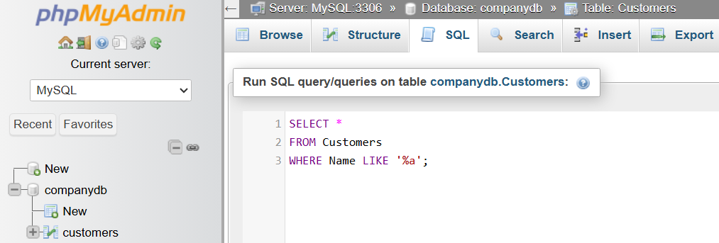
SELECT *
FROM Customers
WHERE Name LIKE '%a';
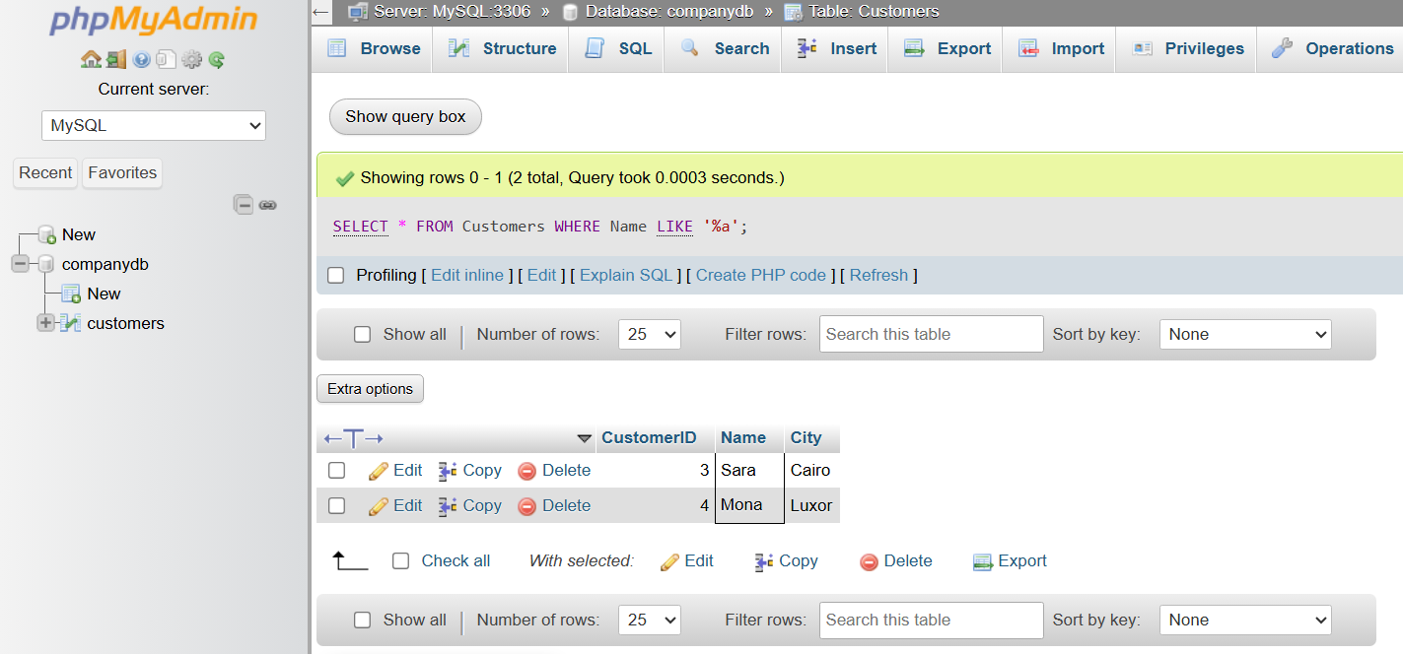

5️⃣ Contains "am"
# Source: ScreenShot Source: Provided by: [Persons Table -> ID Column: 1, Name_En Column: Motasem Essam] -> Tool: [Automation Table -> ID Column: 16, Name_En Column: Screen Capture] -> From [Operating System: Wampserver64 -> phpmyadmin] on [6/11/2026]
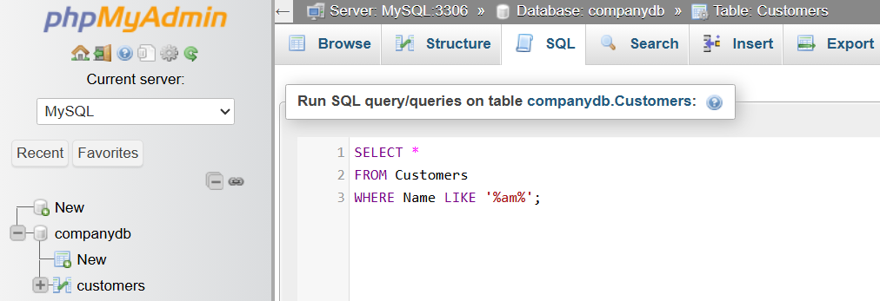
SELECT *
FROM Customers
WHERE Name LIKE '%am%';
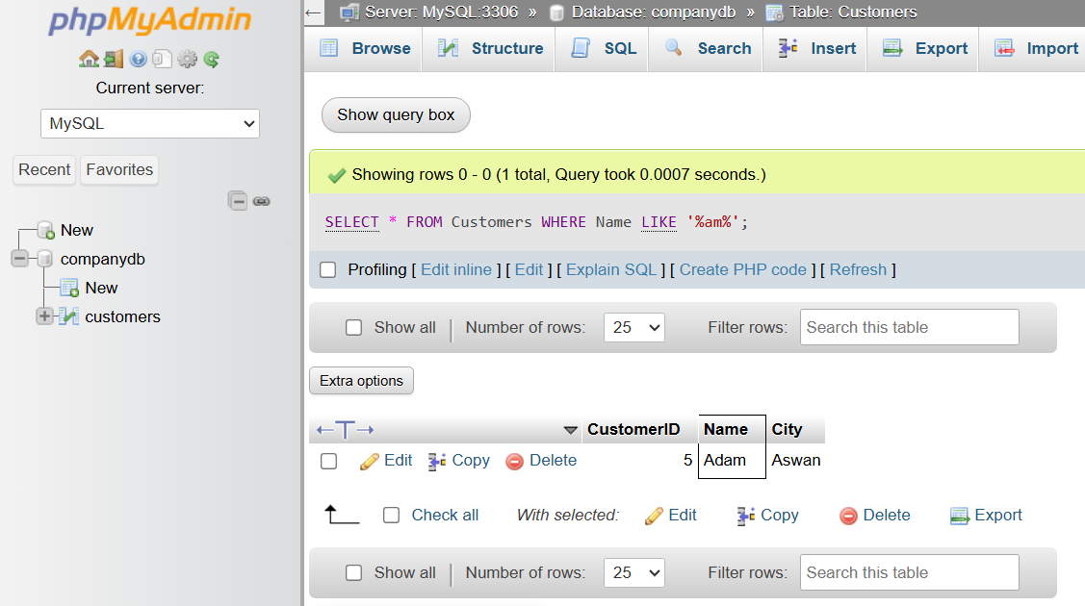

6️⃣ Exactly Four Letters
# Source: ScreenShot Source: Provided by: [Persons Table -> ID Column: 1, Name_En Column: Motasem Essam] -> Tool: [Automation Table -> ID Column: 16, Name_En Column: Screen Capture] -> From [Operating System: Wampserver64 -> phpmyadmin] on [6/11/2026]
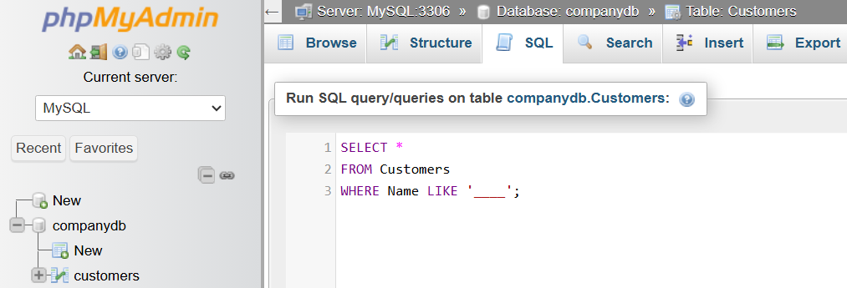
SELECT *
FROM Customers
WHERE Name LIKE '____';
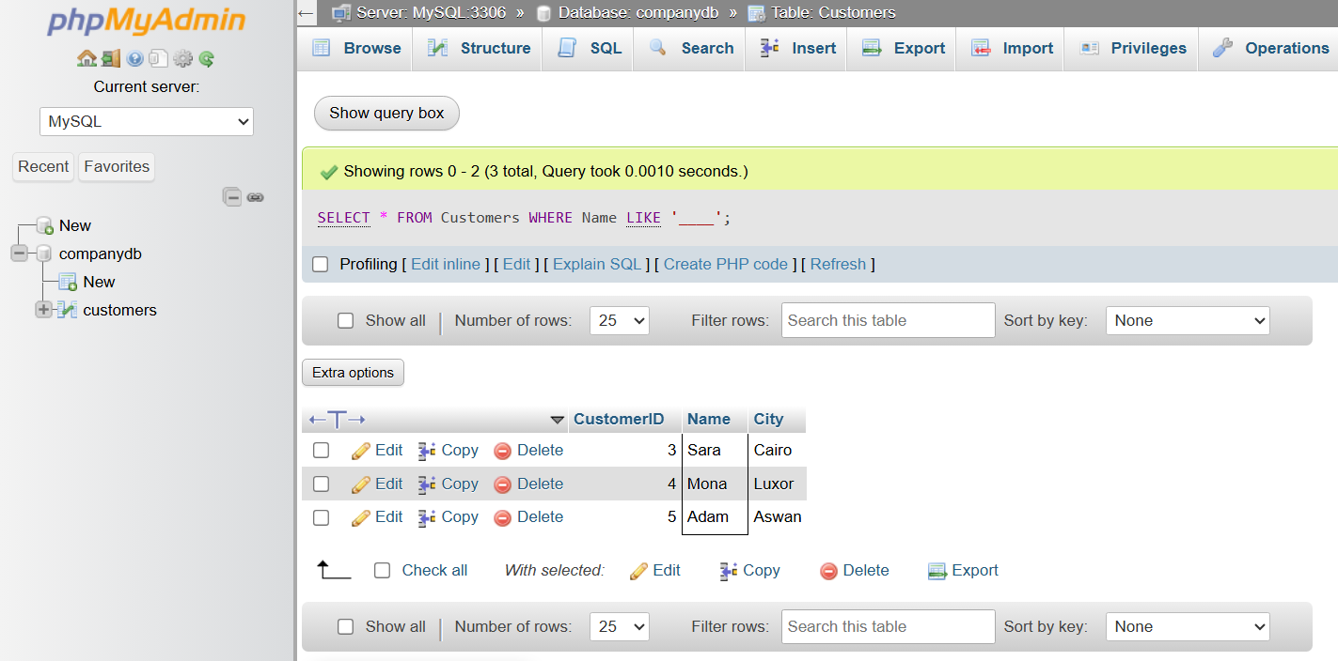

7️⃣ Second Letter is "o"
# Source: ScreenShot Source: Provided by: [Persons Table -> ID Column: 1, Name_En Column: Motasem Essam] -> Tool: [Automation Table -> ID Column: 16, Name_En Column: Screen Capture] -> From [Operating System: Wampserver64 -> phpmyadmin] on [6/11/2026]
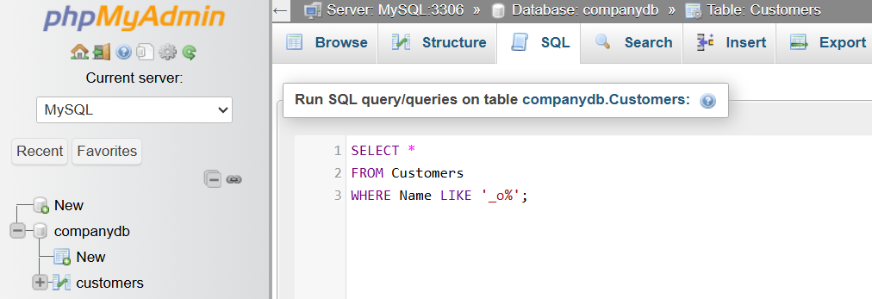
SELECT *
FROM Customers
WHERE Name LIKE '_o%';
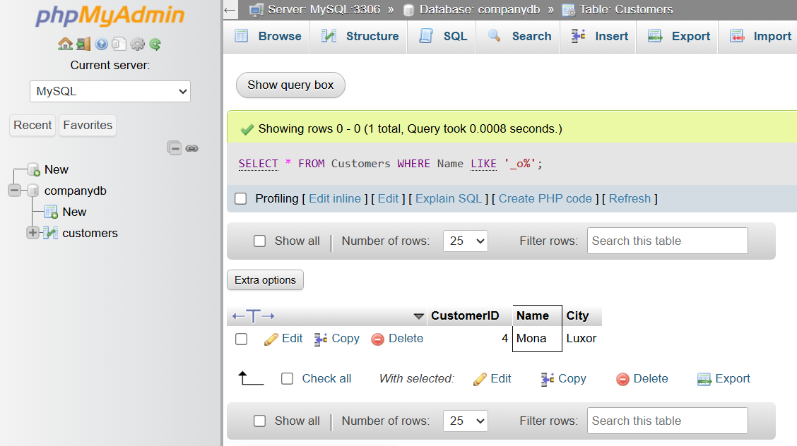

⚖️ LIKE vs =
# Source: AI Source: Provided by: [Data Path: Persons Table -> ID Column: 1, Name_En Column: Motasem Essam] -> From: [ChatGPT] on [6/11/2026]
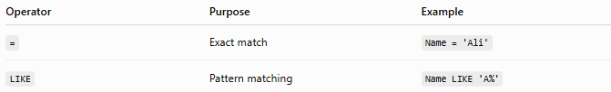
Operator | Purpose | Example
= | Exact match | Name = 'Ali'
LIKE | Pattern matching | Name LIKE 'A%'
Using =
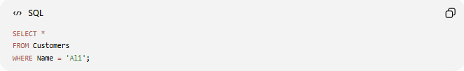
SELECT *
FROM Customers
WHERE Name = 'Ali';
Returns only Ali.

Using LIKE
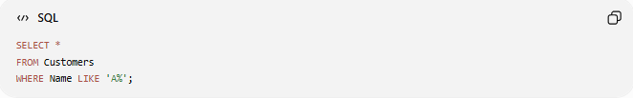
SELECT *
FROM Customers
WHERE Name LIKE 'A%';
Returns Ali, Ahmed, Adam, and any other names starting with A.

🔢 LIKE Workflow
# Source: AI Source: Provided by: [Data Path: Persons Table -> ID Column: 1, Name_En Column: Motasem Essam] -> From: [ChatGPT] on [6/11/2026]
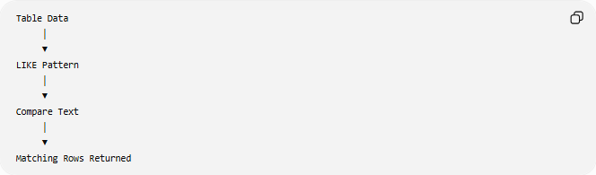
Table Data
│
▼
LIKE Pattern
│
▼
Compare Text
│
▼
Matching Rows Returned

🧠 Simple Analogy
# Source: AI Source: Provided by: [Data Path: Persons Table -> ID Column: 1, Name_En Column: Motasem Essam] -> From: [ChatGPT] on [6/11/2026]
Imagine you're searching your phone contacts.
- Searching "Ali" is like using =.
- Searching "A..." (any name starting with A) is like using LIKE 'A%'.
- Searching for names containing "am" is like using LIKE '%am%'.
Wildcards let you search even when you don't know the complete text.

🧭 Summary
# Source: AI Source: Provided by: [Data Path: Persons Table -> ID Column: 1, Name_En Column: Motasem Essam] -> From: [ChatGPT] on [6/11/2026]
The SQL LIKE operator is used to search for text that matches a specified pattern. It works together with wildcards, where % represents zero or more characters and _ represents exactly one character. LIKE is commonly used with the WHERE clause to perform flexible text searches, making it useful for filtering names, cities, email addresses, and other string data.

